Experiment: Candidate Elimination Algorithm
Aim
To implement and demonstrate the Candidate Elimination Algorithm in Python to find the set of all hypotheses that are consistent with the given training examples stored in a CSV file.
Theory
The Candidate Elimination Algorithm is a concept learning algorithm that computes the Version Space, which is the set of all hypotheses consistent with the training data.
It maintains two boundaries:
- S (Specific Boundary): The most specific hypothesis.
- G (General Boundary): The most general hypothesis.
For every training example:
- If the example is positive, generalize S and remove inconsistent hypotheses from G.
- If the example is negative, specialize G and remove inconsistent hypotheses from S.
Algorithm
- Read the training dataset.
- Initialize:
  - Specific hypothesis (S) with the first positive example.
  - General hypothesis (G) with all ?.
- For every training example:
  - If positive:
    - Generalize S.
    - Remove inconsistent hypotheses from G.
  - If negative:
    - Specialize G.
- Display the final Specific and General hypotheses.
Sample Dataset (Book1.csv)
Sky,AirTemp,Humidity,Wind,Water,Forecast,EnjoySport
Sunny,Warm,Normal,Strong,Warm,Same,Yes
Sunny,Warm,High,Strong,Warm,Same,Yes
Rainy,Cold,High,Strong,Warm,Change,No
Sunny,Warm,High,Strong,Cool,Change,Yes
Python Program
import pandas as pd
import numpy as np
# Load dataset
data = pd.read_csv("Book1.csv")
print("Training Data:\n")
print(data)
# Separate features and target
concepts = np.array(data.iloc[:, :-1])
target = np.array(data.iloc[:, -1])
# Initialize S and G
specific = concepts[0].copy()
general = [["?" for _ in range(len(specific))] for _ in range(len(specific))]
print("\nInitial Specific Hypothesis:")
print(specific)
print("\nInitial General Hypothesis:")
print(general)
for i, h in enumerate(concepts):
if target[i] == "Yes":
for x in range(len(specific)):
if h[x] != specific[x]:
specific[x] = "?"
general[x][x] = "?"
elif target[i] == "No":
for x in range(len(specific)):
if h[x] != specific[x]:
general[x][x] = specific[x]
else:
general[x][x] = "?"
print("\nFinal Specific Hypothesis:")
print(specific)
print("\nFinal General Hypothesis:")
final_g = []
for row in general:
if row != ["?" for _ in range(len(specific))]:
final_g.append(row)
for g in final_g:
print(g)
Output

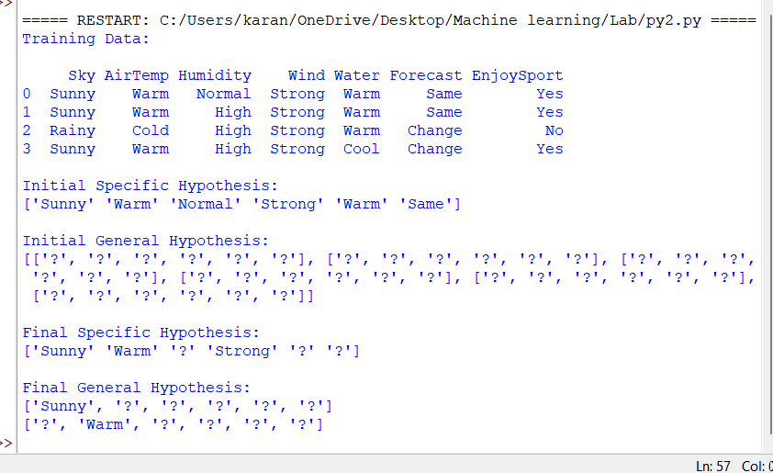

Result
The Candidate Elimination Algorithm was successfully implemented. The algorithm produced the Specific Boundary (S) and the General Boundary (G), representing the version space of all hypotheses consistent with the given training data.

